1. First, we will set up the relationship between rainfall and political party foundings, and then modify the rainfall measure to generate a statistically independent measure for droughts. This modification will allow us to isolate the effect of economic strain on political parties from other underlying features of a region that might influence its political structure.

(A) Create a figure, for example, a scatter plot, showing the visual relationship between the level of rainfall in a district in the period leading up to the current election, and the number of political parties that are founded in a region. You can use the raw rainfall measure or the Standardized Precipitation Index. You can consider the level of rainfall for each election period in terms of (1) the sum of the raw rainfall during the interval starting from the year following the previous election up until the year of the current election or (2) the yearly average of the Standardized Precipitation Index during the interval starting from the year following the previous election up until the year of the current election.

As a first step I read in all the data files separately. For this problem I identified that I would need to aggregate the rain data at the election period level and then combine it with the district data. For this I first created a mapping table to map each individual rain year to an election period year. I did this by taking a unique list of election periods from the district data.

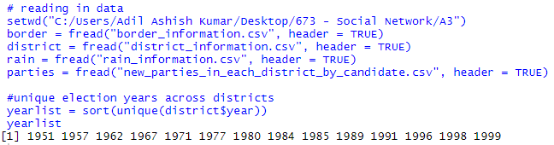

I then created a manual mapping to map each individual rain year to an election period. I joined these 2 to form a mapping table. I am aware that the manual mapping approach is not the best approach since it involves a bit of manual work, but I used it since it was the quickest way for me to get through it.

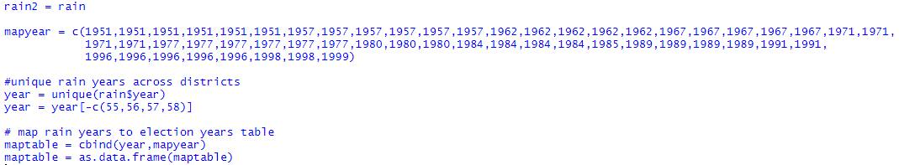

Below is how my mapping table looks.

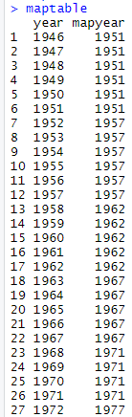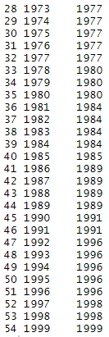

I then joined this mapping table to the rain data. I now have rain data at the election period level

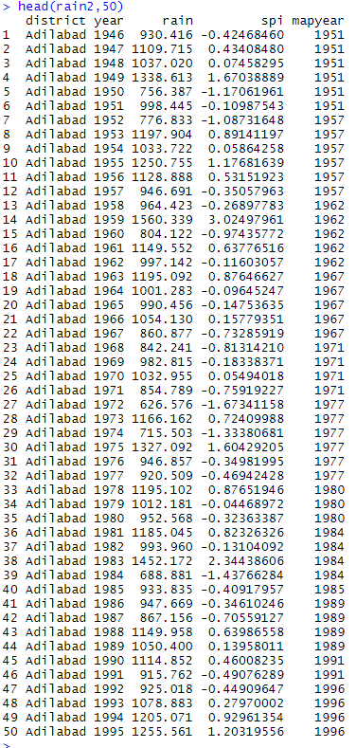

I aggregated the rain data so I have one summed rain entry for each election period by district. For this I used aggregate, specified to aggregate by district- election year and used sum function to aggregate the values.

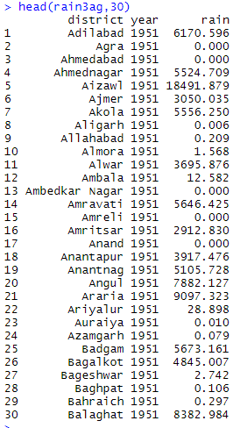

I did the aggregation for SPI separately to get the mean SPI for an election period. I used the aggregate function similarly as as for rain but used mean function instead of sum in this case



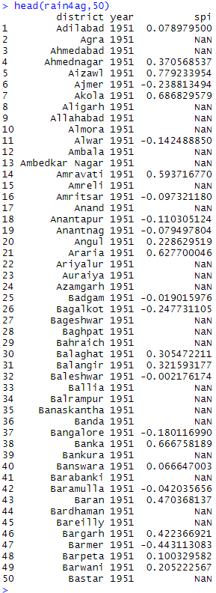

Now that I have aggregated rain and spi at the election period level per district, I join these 2 to get both measures into 1 dataframe



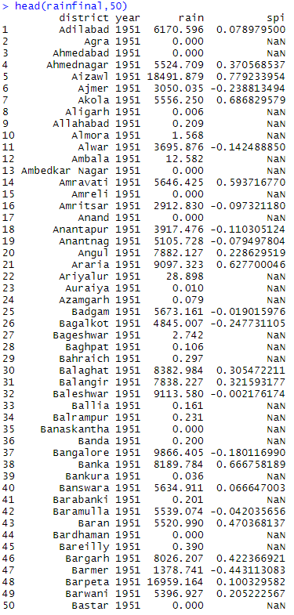

I then joined this data into the district data so that I can create our required plot

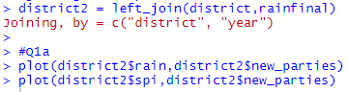



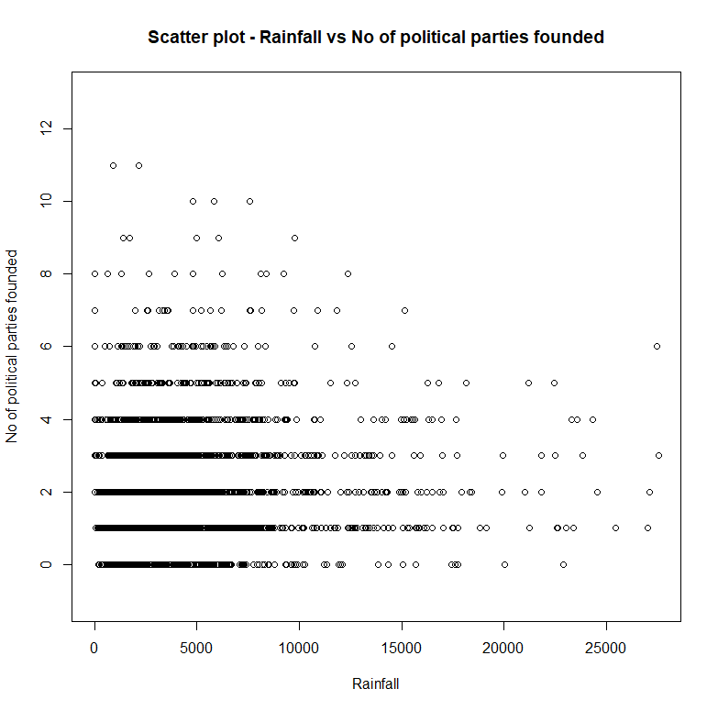

Above we see the scatter plot of rainfall vs no of political parties founded. Based on the graph it seems like most of our data points are concentrated in the region where rainfall is between 0 -10000 and no of parties = 0-4 approximately. On the right, we can see that there are very few instances of district-years where a large no of parties were founded when there was high rainfall. Overall, we can say that on average, district-years which received low- moderate rainfall had lesser no of parties founded. We can see that at extremely high rainfall (20000-25000) the max no of parties founded is about 6. We can see that there are very few districts where no of parties founded is >=10 and these occur when rainfall is 0-10000.

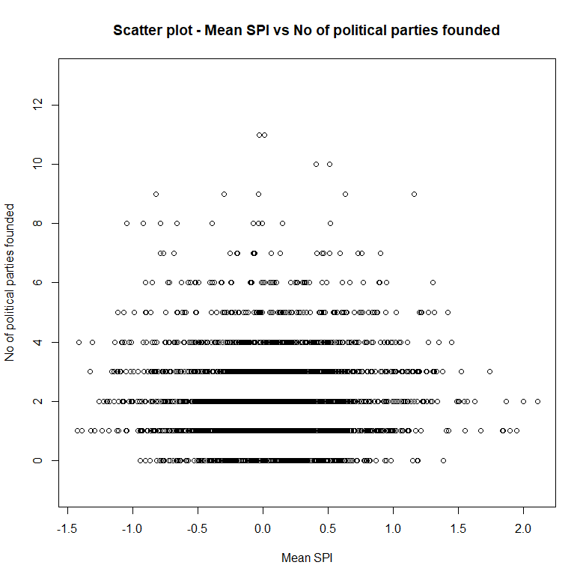

Above we see the mean SPI scatter plot vs no of political parties founded. We can see that majority of the district years had an avg SPI of -1 to 1. Most of these district years had on average about 0-4 new parties formed. On the extreme ends we can see that there are fewer no of parties formed. We can see where avg SPI is about 2, the max no of parties formed is about 2 or 3, and when SPI is about -1.5, max no of parties forms is about 4. The instances where max no of political parties formed are when mean SPI is about -0.5 to 0.5. Overall, we can say that extreme SPI conditions do not lead to higher no of political parties formed compared to when SPI is more centered (-1 to 1)

Overall, from both graphs we can see that in cases of extreme weather there are lesser no of political parties formed than during moderate rainfall. This indicates that increased economic strain tends to hinder political activity.

(B) Using the election-period level rainfall measures created above, show that the raw level of rainfall, as well as the Standardized Precipitation Index, are not independent from one election period to the next within a district, as well as from neighboring districts from one election period to the next. It is possible to show this relationship by regressing a district’s current level of the rainfall variable on (1) its lagged value and (2) the lagged value of its neighbors’ rainfall variable. For computing the neighbors’ value, you can use an average of each of the

surrounding districts’ values.

Include a control in the regression for the number of years in the election period, and use a fixed effects specification to control for the time-invariant features of a district as well as a control for each election period. This can be accomplished using the plm package, using a model specified in the form of plm(outcome variable _ predictor variables, data, effect = "twoways", model = "within", index = "district"), where "twoways" "within" provide both sets of fixed effects.

For this question, I needed to calculate the lag of rain for a district and the lag of avg rain of districts border districts. I began by taking out only district – year wise rain and new parties formed. I grouped the data by district and arranged the data by year within district so that it is ready for lag calculation. I then used the mutate function to calculate the lag column based on year for each district. This gives the lagged rain data by district.

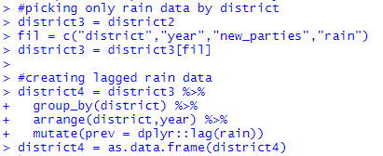

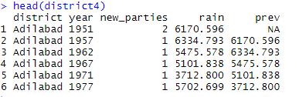

I then used this above dataframe and kept only district- year wise lagged rain data.

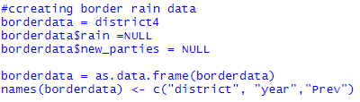

I joined this dataframe to the border data frame that has focal district wise border district data. I dropped 0s from the year column since it was redundant data created from the join process. I replaced NAs in lagged column by 0s.

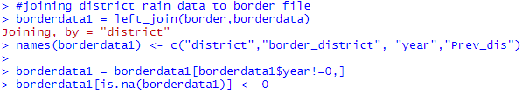

I now have district wise border district lagged rain data by election year.

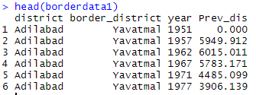

I then aggregated this data to show the avg lagged rain data across all bordering district for a particular district. I used the aggregate function to do so and made sure the aggregation was done at focal district- year level, so that for each focal district – year combo, I have its avg lagged border rain data. I used the mean function inside aggregate to get avg of all border values for a district.



Now that we have the lagged border rain data, I am joining it back to original data that has district year wise rain and lagged rain data.

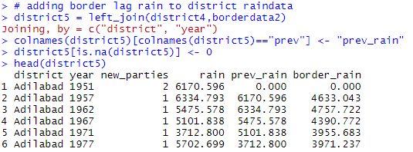

Now I need the no of years in each election period since its needed for the regression. For this I used the mapping table that I created earlier.

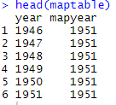

I used the aggregate function to first find the starting year of every election period. I used the min function inside the aggregate to find the first year of election period. Below we can see the resulting dataframe with election period and its corresponding start year.

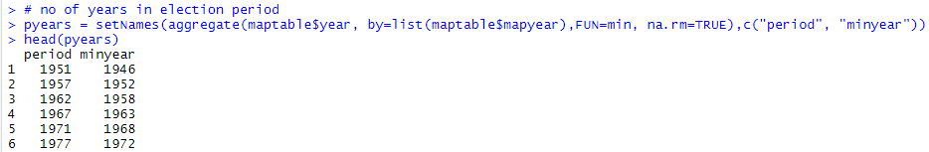

I then used this to calculate the no of years by taking a difference between election period and minyear and added 1 to consider the current year as well. Below shows the resultant dataframe with election period wise count of years.

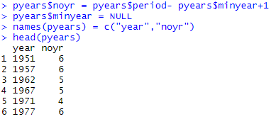

I then joined this data frame back to the original dataframe that has rain, lagged rain and lagged border rain for each district. Below we see the data that’s ready for regression.

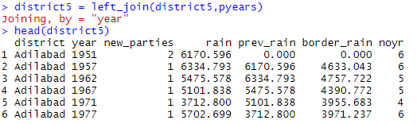

I then used the plm package as instructed to see the relationship between a districts current rain based on its lagged rain, its lagged border rain and no of years in the election period. Below is the regression summary output.

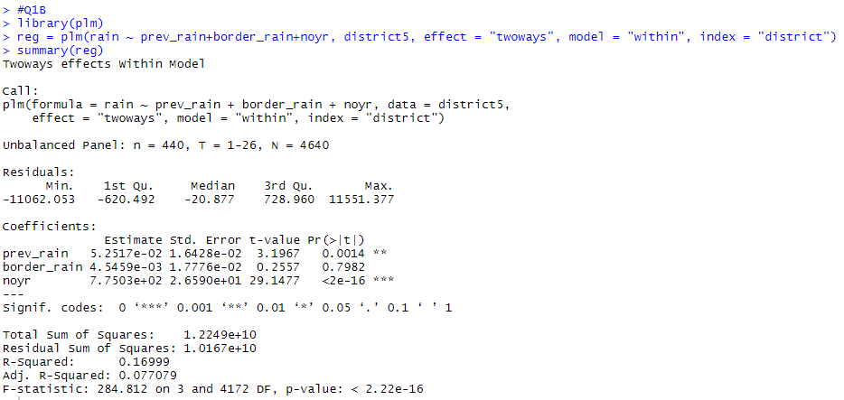

We can see that the most significant variable is the no of years. This is obvious since, the more years in the election period, the more rainfall would be there since its adding more years of rainfall. We can see that the lagged rainfall of a district is the second most important variable. It also has a very low p value, indicating high variable significance. The border rain has the least significance in the model. We also see that the t value is very low(<2) and p value is really high, indicating its not at all a significant variable in the model.

Overall we can say that from the model that rainfall is not independent of rain from previous election period. The low significance of border district previous election rain may indicate that rainfall in a district may not be very dependent on the border district previous election rain.

Now to find the lagged SPI and lagged border SPI for each district, I did the exact same process I followed for the rainfall case. Since I had created avg SPI data by district created for Q1a, I will use the same to calculate the lag and border lag columns.

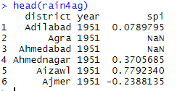

I used the same mutate function to find the lagged SPI by district. I grouped the data by district and arranged the data by year within district so that it is ready for lag calculation. I then used the mutate function to calculate the lag SPI column based on year for each district. This gives the lagged SPI data by district.

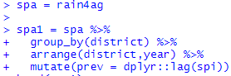

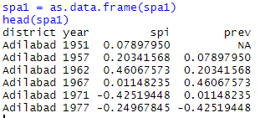

I then used this above dataframe and kept only district- year wise lagged SPI data.

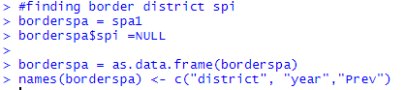

I joined this dataframe to the border data frame that has focal district wise border district data. I dropped 0s from the year column since it was redundant data created from the join process. I replaced NAs in lagged column by 0s.

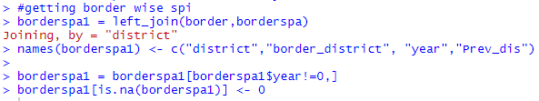

I now have district wise border district lagged SPI data.

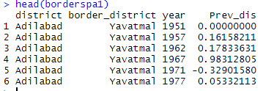

I then aggregated this data to show the avg lagged SPI data across all bordering district for a particular district. I used the aggregate function to do so and made sure the aggregation was done at focal district- year level, so that for each focal district – year combo, I have its avg lagged border SPI data. I used the mean function inside aggregate to get avg of all border values for a district.



Now that we have the lagged border SPI data, I am joining it back to district year wise SPI and lagged SPI data. I also replaced NAs by 0s in the data.

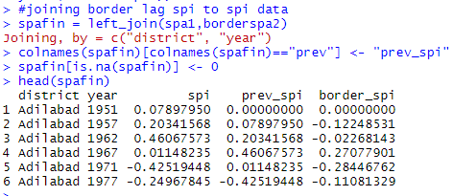

I then extracted the district year wise new party data columns from my rain dataset I used in the previous regression model.

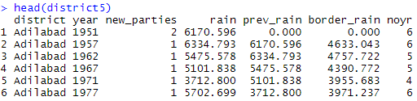

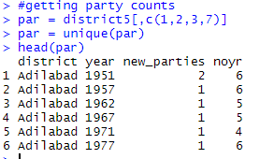

I then joined this to my lagged SPI data so that I can use it in the regression model. Below is the ready SPI data that we can use in the regression model.

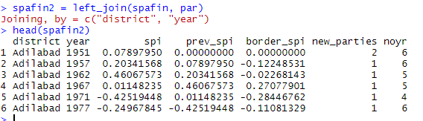

I then used the plm package as instructed to see the relationship between a districts current SPI based on its lagged SPI, its lagged border SPI and no of years in the election period. Below is the regression summary output.

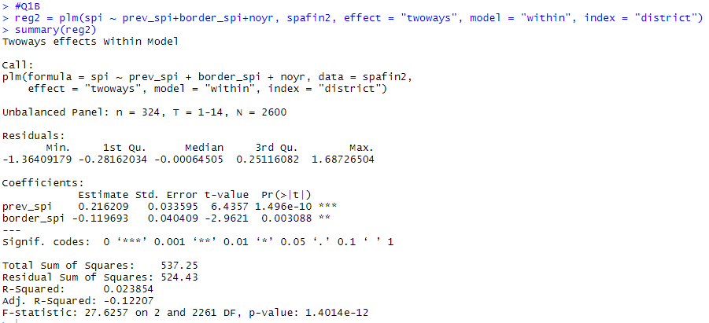

Based on the regression output above, we can see that the districts lagged SPI is the most important variable. We see that its t value is very high(>2) and its p value is very small. This indicates that it is a very important variable in the model. A districts lagged border SPI has a lesser significance in the model. Its t value is very low(<2), but its p value is small. This indicates that the border lagged SPI is significant in the model. Overall, we can say from model output that a districts current SPI level is not independent of districts lagged SPI and its border district lagged SPI levels.

(C) Meteorological scientists consider moderate droughts to occur if the Standardized Precipitation Index falls below -1, and moderate floods to occur if it rises above 1.

Create a measure that sums the number of years a district experiences either moderate droughts or floods during the interval starting from the year following the previous election up until the year of the current election. Perform the same test as in (B), using this new transformed measure. This measure will form the basis for the predictors used in the remainder of the regressions in Questions 2-5.

Since this is a count outcome that is reported as a discrete number of years, use a regression adopted for data of this form—this can be accomplished with the pglm package, using a model specified in the form of pglm(outcome variable _ predictor variables, data, effect = "twoways", model = "within", index = "district", family = "poisson"). What differences do you see between the estimates?

For this question I need to create a column that indicates presence or absence of drought/flood using SPI. I first take the original rain data. I then drop the rain column since I need only SPI. Based on SPI I create a new column to indicate drought/flood if SPI >1 or SPI <-1. I then use my mapping table created earlier to bring in the election period years since we need that and not rain years. I then drop SPI and year columns. Now I have District-year wise presence or absence of drought/flood.

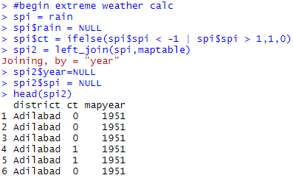

I then used the aggregate function to sum up these occurrences of drought/flood to give the sum of years when drought/flood within a election period for a given district. Below is required dataframe.

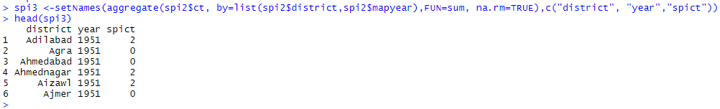

Once again, to find the lagged and lagged border values, I use the same approach as I used for rain and SPI for Q1b. First I used mutate to find lagged values.

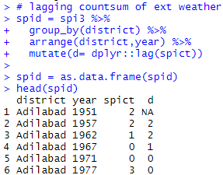

Then I duplicated above and dropped non lagged column. I now have district-year wise lagged values

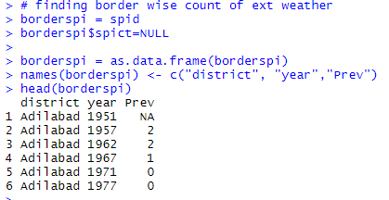

I then joined above to border list to get border wise lagged values.

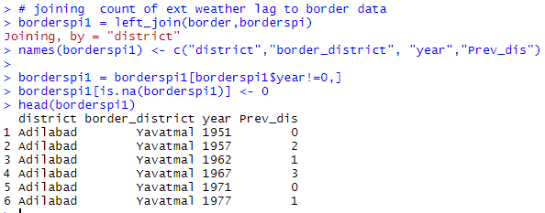

I then used aggregate to average all values of borders for a district to get district wise avg border lagged value

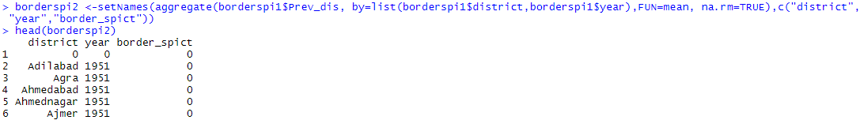

I then joined this to the original district year wise sum of drought/flood occurrences. Now we have district-year wise sum of drought/flood occurrences, lagged sum of drought/flood occurrences, avg border lagged sum of drought/flood occurrences

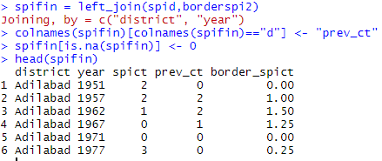

I then join the new party count by district year and the no of years per election period into the above. Below is final dataframe ready for regression

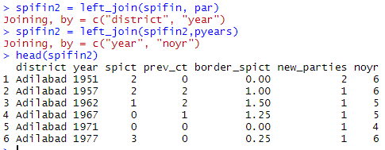

As instructed, I used the pglm package to predict no of drought/flood occurrences based on lagged values and lagged values of border districts

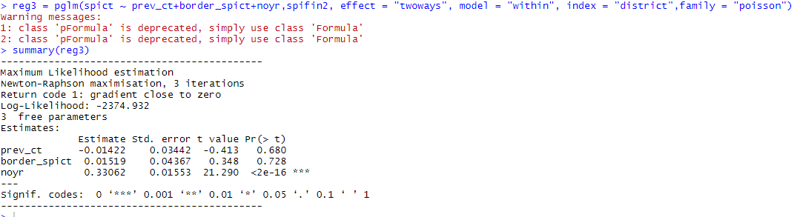

From above regression output we can see that no of years in election period is most significant. This is obvious since more the no of years in a period having drought/flood, more will be the occurrences of drought/flood in an election period. We can see that the other 2 variables however are not significant in the model. Both lagged and border lagged value have low t values (<2) and high p values. This indicates they are not statistically significant in predicting occurrence of drought/flood.

The clear difference between this model and previous 2 models is that lagged rain and SPI values are strong predictors in predicting rain and SPI while in this model lagged sum of occurrences of drought/flood in a district as well as border districts is not a good predictor in predicting occurrences of drought/flood.

2. Next, let’s analyze whether there are more new political parties when droughts or floods

occur.

Run a regression predicting the number of new political parties that are formed as a function of the number of years a district experiences droughts or flooding in the interval starting from the year following the previous election up until the year of the current election.

The number of new political parties that enter a district is a discrete count outcome. However, it is likely that the rate of entry of political parties in any particular district in a particular period is also related, or “autocorrelated”, over time, to the rate of entry in the prior period’s of this district’s history. As a result, we will use a feasible generalized least squares estimator that can take into account district-specific autocorrelation. This can be accessed through the panelAR package using a model of the form panelAR(outcome variable _ predictor variables, data, panelVar, timeVar, autoCorr = "psar1", panelCorrMethod = "phet", rho.na.rm = TRUE).

In this regression, we are specifying district fixed effects through “phet” and panel-specific autocorrelation through “psar1”. Also include a control in the regression for the number of years in the election period and a linear control for each election year.

In addition to modeling the effect of extreme weather on the overall entry of new parties, do certain kinds of political parties seem to be more likely than other kinds to be formed when a district experiences extreme weather?

For this question I don’t need to do any data prep since I have all variables readily prepared as needed for earlier questions. As instructed I used the panelAR function to predict no of new parties formed based on no of occurrences of flood/drought and no of years in election period. I indicated panelVar as district and timeVar as year.



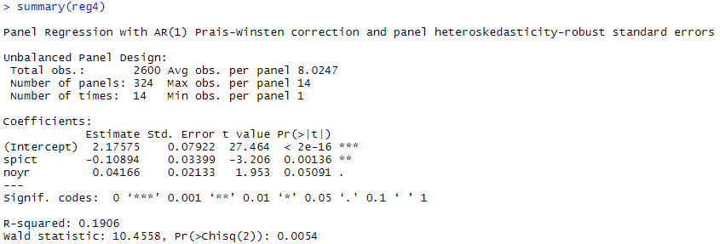

Above we can see summary of the model output. We can see that no of occurrences of flood/drought is the most significant variable in the model. The t value is very high (>2) and the p value is very low. This indicates that the variable is very highly significant. We see that t value of no of years in election period is low (<2) and p value is not very high. This indicates the variable is not very significant. Overall we can say that formation of new political parties is dependent on no of occurrences of flood/drought in a district. It is more likely that new parties are formed when drought/flood occurs.

In order to see if certain types of parties were morelikely than others to form in extreme weather, I ran individual regressions to predict new caste, socialist, communist and secular parties based on no of years in election period and extreme weather in district



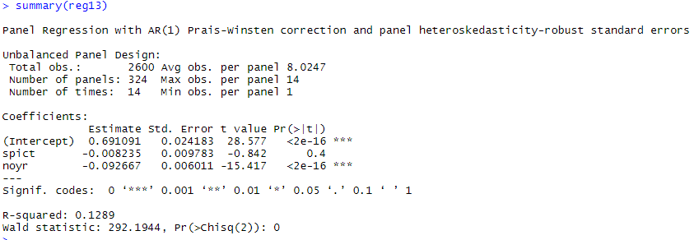

In case of new caste parties, extreme weather is not significant



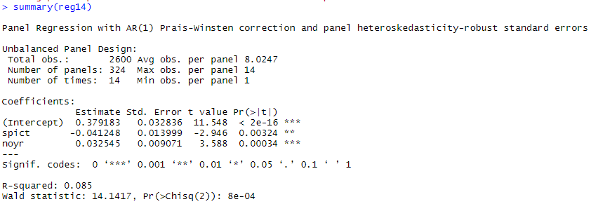

In case of new socialist parties, extreme weather is significant



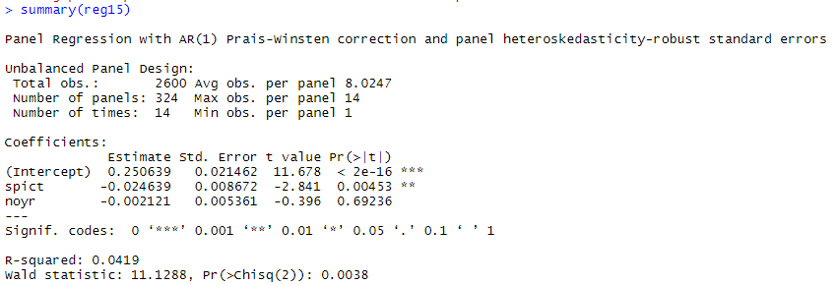

In case of new communist parties, extreme weather is significant



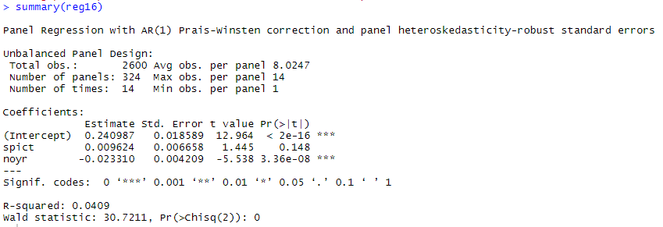

In case of new secular parties, extreme weather is not significant

From above regression outputs it is clear that some type of parties are more likely to form when there is extreme weather in a district than others. Caste and secular parties are not likely to form in extreme weather while communist and socialist parties are more likely to form when there is extreme weather in district.

3. Now that we have established the baseline effect, we can look at how political activity stimulated by droughts or floods in one district might affect political activity in another district.

Use a similar regression to Question 2 to show that, even when taking into account a district’s own droughts and floods, the level of entry of new political parties in a district will also depend on the number of years its neighboring districts experience years of droughts or flooding in the interval starting from the year following two elections ago, up until the year of the previous election—the election lead-up interval before the current one.

Similar to Question 2, include a control in the regression for the number of years in the current election period, a control for the time-invariant features of a district as fixed effects, and a linear control for each election year.

For this question I don’t need to do any data prep since I have all variables readily prepared as needed for earlier questions. As instructed I used the panelAR function to predict no of new parties formed based on no of occurrences of flood/drought in a district, lagged no of occurrences of flood/drought in border district and no of years in election period. I indicated panelVar as district and timeVar as year.



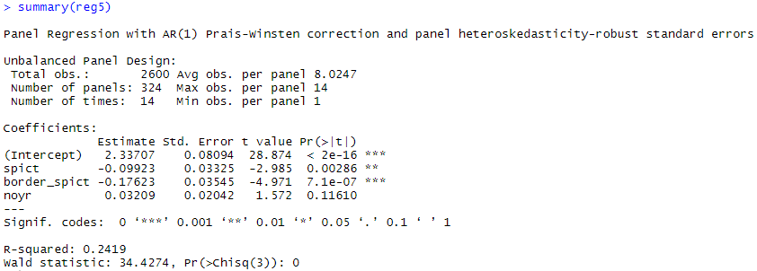

From the model we can see that the most significant variable is the lagged no of occurrences of drought/flood in border district. It has a low t value (<2) but very low p value, indicating very high significance in the model. The 2nd most significant variable is the no of occurrences of drought/flood in a district. No of years in election period in the model does not have any significance.

Overall we can say that political activity stimulated by droughts or floods in one district does affect political activity in another district. This could be due to diffusion effects across districts.

4. Extreme weather events like droughts or floods can erode the stability of political systems and wear away at the entrenched power bases of large, national-scale parties that have difficulty responding to the needs of affected regions.

(A) Does experiencing droughts or floods relate differently to the entry and diffusion of political parties depending on their scope?

Perform regressions, similar to Question 3, one each predicting the entry of new national, state, and regional scope parties as the outcome based on extreme weather in a district in the period leading up to the current election and based on extreme weather in neighboring districts in the period leading up to the prior election.

Include a control in the regression for the number of years in the election period, a control for the time-invariant features of a district, and a linear control for each election year.

I created a dataframe having the new parties columns for national scope, state scope regional scope and the political concentration columns by district year from the original district level input data. I then joined it to our dataframe that I used in previous question. The below dataframe is what is needed for the regression.

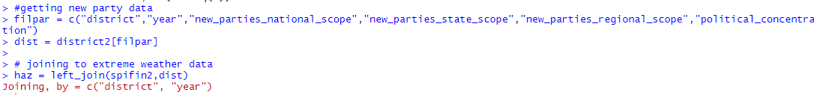

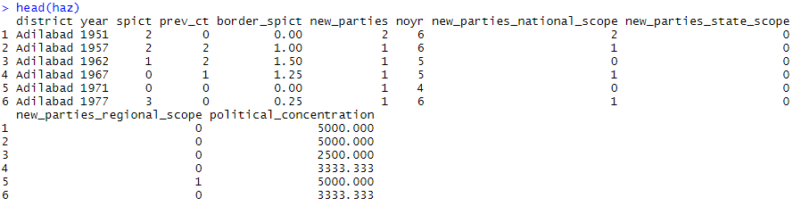

I then used the panelAR function to predict new parties_national scope formed based on no of occurrences of flood/drought in a district, lagged no of occurrences of flood/drought in border district and no of years in election period. I indicated panelVar as district and timeVar as year.



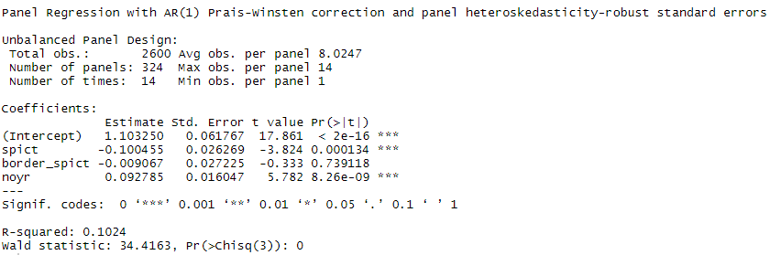

From model output we can see that no of occurrences of flood/drought and no of years in election period have highest significance. The no of years in election period has higher t value and lower p value than the no of occurrences of flood/drought. The no of lagged occurrences of flood/drought in border district has least significance in the model. It also has very high p value, indicating it is not very significant. This makes sense since these parties are of national scope and may not be dependent on what happens between districts. Overall it seems formation of new national parties in a district is more dependent on no of years in election period and no of occurrences of flood/drought in that district.

I then used the panelAR function to predict new parties_state scope formed based on no of occurrences of flood/drought in a district, lagged no of occurrences of flood/drought in border district and no of years in election period. I indicated panelVar as district and timeVar as year.



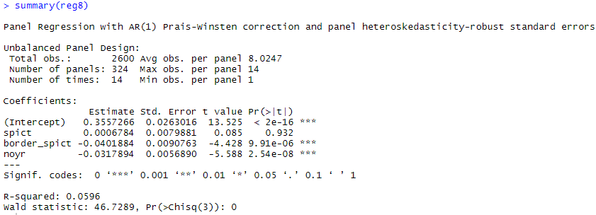

From model output we can see that no of lagged occurrences of flood/drought in border district and no of years in election period have highest significance. The no of years in election period has lower p value than no of lagged occurrences of flood/drought in border district. The no of occurrences of flood/drought in district has least significance in the model. It also has very high p value, indicating it is not very significant. We can see this reverse in comparison to the previous model where the no of lagged occurences of flood/drought in border districts is more significant than no of occurrences of flood/drought in the district. This makes sense since districts within a state will have an effect on each other and hence new parties of state scope formation depends on what happens in the border district 2 elections ago.Overall it seems formation of new state parties in a district is more dependent on no of years in election period and no of lagged occurrences of flood/drought in border district.

I then used the panelAR function to predict new parties_regional scope formed based on no of occurrences of flood/drought in a district, lagged no of occurrences of flood/drought in border district and no of years in election period. I indicated panelVar as district and timeVar as year.



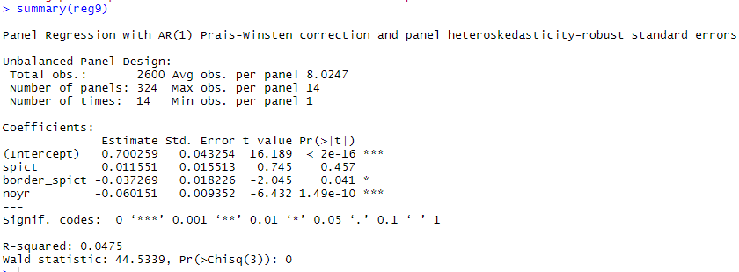

From model output we can see that no of years in election period has highest significance. The no of years in election period has very low p valuem indicating it is very significant. The no of lagged occurrences of flood/drought in border districts has second highest significance in the model. It has a small p value, indicating it is slightly significant. The no of occurrences of flood/drought in district has least significance in the model. It also has very high p value, indicating it is not very significant. It is interesting to note how the occurrence of drought flood both in the district and its border districts are not very significant in this case .Overall it seems formation of new regional parties in a district is more dependent on no of years in election period.

Looking at the regression outputs for all 3 models, we can summarize that in case of national scope parties, formation of parties is dependent only on extreme weather in a district but not in border districts.

In case of state scope parties, formation of new parties depends more on extreme weather in border districts. This means. In case of regional scope parties, formation is not very dependent on extreme weather in general.

We can clearly see that experiencing droughts or floods does relate differently to the entry and diffusion of

political parties depending on their scope. The diffusion of political activity for each party type is different and not necessarily dependent on extreme weather.

(B) Does experiencing droughts or floods relate to political concentration?

Perform a regression, similar to Question 3, predicting the Herfindahl Index of a region as a function of the number of years of droughts or flooding that occur in a district in the interval leading up to the current election, and the number of years of droughts or flooding that occur in its neighboring districts in the interval leading up to the previous election.

Include a control in the regression for the number of years in the election period, a control for the time-invariant features of a district, and a linear control for each election year.

What does this result illustrate in terms of the concentration or fragmentation of political power in districts affected by extreme weather?

I used the panelAR function to predict political concentration based on no of occurrences of flood/drought in a district, lagged no of occurrences of flood/drought in border district and no of years in election period. I indicated panelVar as district and timeVar as year.



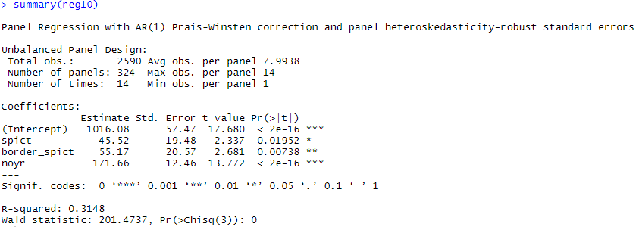

We can see from model output that all 3 variables are significant. The no of years in election period is most significant, while the no of occurrences of flood/drought in a district is least significant. This result illustrates that concentration of political power is more dependent on the no prevalence of extreme weather in previous elections in neighboring districts than on prevalence of extreme weather in the district itself.

Overall, political concentration does depend on the occurrence of extreme conditions. The political concentration is affected by extreme weather. It increases with occurrence of extreme weather conditions.

5. Political parties are formed to accomplish a variety of goals. Individual parties can also exist in the context of larger social and cultural trends, especially when regions influence each other as political organizing activity diffuses across regions over time.

To understand the diffusion process more, we want to analyze whether the new parties that appear in a district are the same parties that have appeared in neighboring districts in the past, or if it the process of political organization, rather than the content of a specific political party, that is diffusing.

To analyze this, run two separate regressions predicting the likelihood of (1) new political parties being founded in a district, that have contested an election in a neighboring district in any previous election period, and (2) new political parties being founded in a district that have not contested an election in a neighboring district in any previous election period.

As in Questions 3 and 4, estimate these as a function of the number of years of droughts or flooding that occur in a district in the interval leading up to the current election and the years of droughts or flooding that occur that occur in its neighboring districts in the period leading up to the prior election.

Include as controls in the regression the number of years in the election period, the timeinvariant features of a district, and a linear control for the election year.

What does the results illustrate about the level and process diffusion of political organizing?

This question requires to find the no of new parties formed per district that were present in previous elections in neighboring district and the no of new parties formed in a district that were not present in previous elections in neighboring districts.

First I created a dataframe having district year wise new party name formed, by filtering the new party input file. I then filtered out duplicates and dropped blank party names.

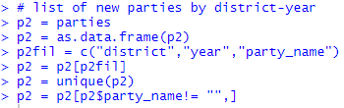

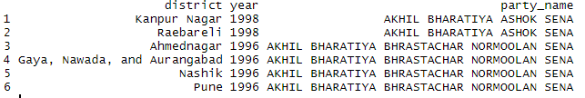

I then joined this to the border data having focal district- border district info.



Now we have names of new parties formed in each border district for each focal district.

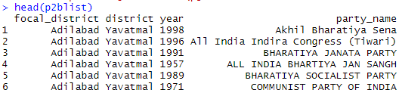

Next, I created a vector having distinct districts in district input file. I then joined this with the new party names dataframe I created. Now I have all new parties that were formed in each focal district.

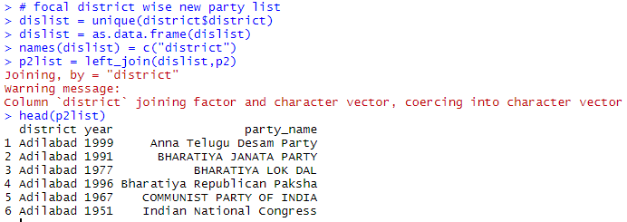

From the border data frame having new party name data, I dropped border district column and then removed duplicates. Now I have list of new parties formed in all border districts of a focal district.

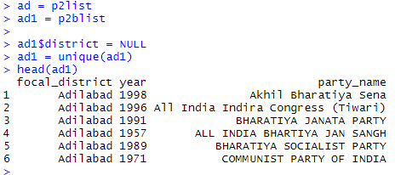

Now I wanted to find when was the earliest a new party was formed within a district among all its occurrences across border districts. For this I used the aggregate function to find the min year for a particular district party name combo.

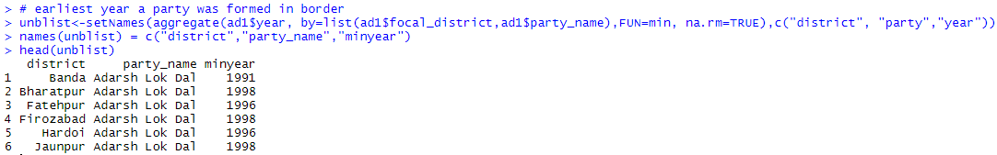

I then joined the above to focal district year wise list of all parties formed in all bordering districts. I now have a dataframe that tells me what was the earliest year a new party was formed across all border districts for a focal district. I then created a flag column to indicate if a party was present in a neighboring district in a previous election or not.

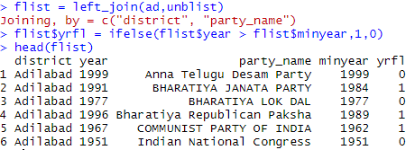

I then aggregated the above the get a sum of new parties formed in a focal district that were present in previous elections in border districts.

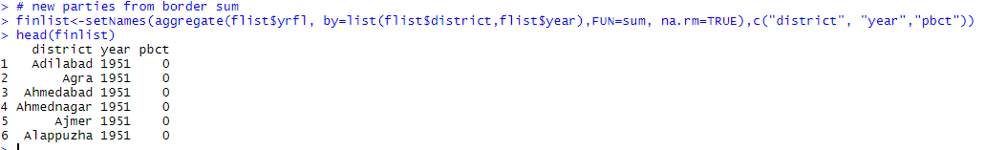

I now need to know how many total new parties were formed in a district. For this I used the district-year new party data. I then added a new dummy column with 1 for every row. I used aggregate to sum this column for each district year combo. Now I have the total no of new parties formed per district.



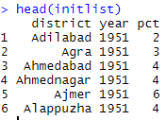

Now that I have 2 data frames – with total no of new parties for a focal district and new parties formed that were present in border districts in previous elections, I joined the 2 into 1 dataframe. I then calculated the no of new parties formed that were not present in border districts in previous elections by subtracting the total no of new parties for a focal district and new parties formed that were present in border districts in previous elections.

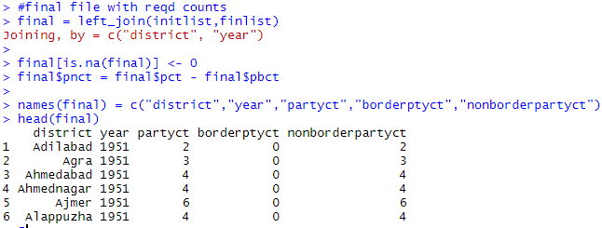

I then used the district year wise extreme weather data and joined it to the above dataframe. I now have the data needed for the regression.

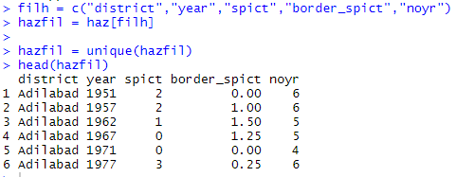

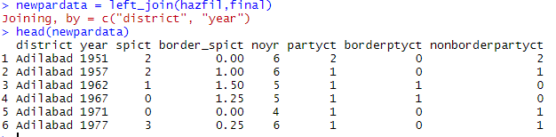

I used the panelAR function to predict new political parties being founded in a district, that have contested an election in a neighboring district in any previous election period based on no of occurrences of flood/drought in a district, lagged no of occurrences of flood/drought in border district and no of years in election period. I indicated panelVar as district and timeVar as year.



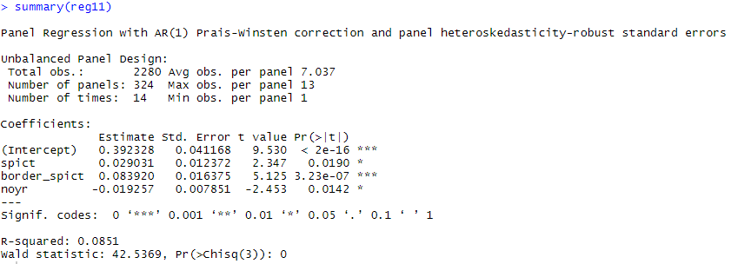

Above is the regression output. Drought/flood occurrences in neighboring districts in previous elections is the most significant variable. This makes sense since we are predicting the new parties that existed in neighboring districts in previous elections. The other 2 variables have similar significance in the model. Extreme weather in neighboring districts leads to more parties formed in those districts, which in turn leads to the same new parties formed in the focal districts. In this case we can see that the new parties that appear in a district are the same parties that have appeared in neighboring districts in the past.

For the 2nd model, I used the panelAR function to predict new political parties being founded in a district, that have not contested an election in a neighboring district in any previous election period based on no of occurrences of flood/drought in a district, lagged no of occurrences of flood/drought in border district and no of years in election period. I indicated panelVar as district and timeVar as year.



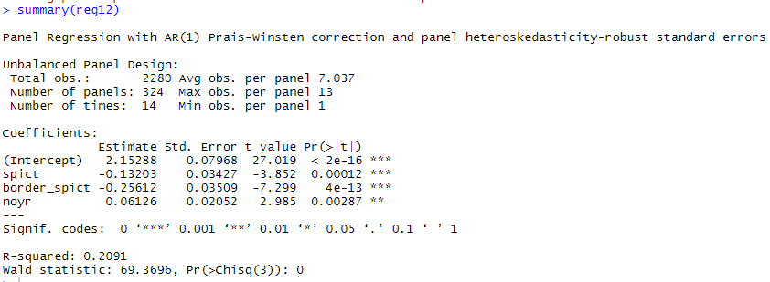

Above is the regression output. Its interesting to note that the model says both drought/flood occurrences in a district and drought/flood occurrences in border districts in previous elections are equally the most significant variables. This means that new parties are being formed as a result of economic disruption in a district and in neighboring districts in previous elections. This also tells us that there is a diffusion in political organizing activity across districts. We can clearly see from this that diffusion of political organizing activity is spreading across districts. By intuition, again it makes sense since these new parties are being formed due to political activity diffusion across districts than due to drought/flood in the district or no of years in election period. Thus we can see that diffusion of political activity does occur across districts.